Daybook Posting – Discussion Document

Contents

Overview 1
About the diagrams 1
Details 3
Prepare and display the filter dialog 3
Prepare the list of document types 3
Add to the thread queue 3
Prepare and display the Job Costing options dialog 3
Add the Job Costing task to the thread queue 3
Control Posting (PostingU.pas) 4
Check any hook points 4
Process Auto transactions 4
Process batch transactions 4
Process transactions 4
Auto-Transactions 5
Auto Transaction Posting 6
Prepare job-costing 6
Prepare notification hook 6
Adjust list of document types 6
Prepare print forms 6
Locate first Auto record 6
Check for on-hold or suspended 6
Save record position 6
Read and adjust currency rates 6
Determine period/year or date 6
Calculate the due date 6
Store operator name 7
Determine VAT date 7
Set document allocation status 7
Assign next document number 7
Assign next folio number 8
Generate transaction lines 8
Save transaction 8
Update balance 8
Print report 8
Call hook point 8
Update or delete auto transaction 8
Locate next auto record 9
Print reports 9
Update Balances 10
Locate the customer/supplier record 10
Prepare the credit/debit amounts 10
Update the balance history 10
Update ‘last edited’ flag 10
Post To History 11
Locate history record 11
Calculate balances 11
Post To Year To Date 11
Timings 11
Batch Transactions 12
Allocate Batch Transactions 13
Prepare job-costing 13
Locate first batch record 13
Increment PostingCount 13
Update LastFolio 13
Check transaction 13
Lock record 13
Post details 13
Save record 13
Update customer/supplier balance 13
Next record 13
Post Batch Details 14
Locate batch transactions 14
Lock record 14
Determine VAT Date 14
Set document allocation status 14
Save record 14
Update customer/supplier balance 14
Update Job Costing 14
Find next record 14
Update Job Actuals 15
Locate record 15
Check transaction line 15
Assign/calculate values 15
Save record 15
Post Adjustment Details 16
Check Stock Valuation flag 16
Create Nominal Transfer record 16
Locate transaction lines 16
Update history 16
Substitute stock parameters 16
Get nominal codes 16
Call hook point 16
Add stock valuation lines 16
Add Job Costing uplift 16
Finalise transaction line 16
Finalise transaction 16
Main Posting 17
Main Transaction Posting 19
Initialise 19
Check transaction 19
Prepare transaction for editing 19
Post transaction lines 19
Post control code lines 19
Finalise transaction 19
Post Nominal Codes 20
Print summary report 20
Post Details 21
Locate first transaction line 21
Calculate totals 21
Update balance history 21
Process pay-in lines 21
Process job costing 21
Finalise transaction line 21
History Posting Code 22

Overview
Daybook Posting is launched via the Daybook Post button on the Daybook dialog.

This then displays a list of document types, to allow the user to include/exclude the document types for the posting run.

The Daybook Post task is added to a thread list so that the user can continue with other Exchequer tasks while the posting routine is in process.

The posting routine starts with Post Auto Transactions, which adds transaction records for all the relevant Auto transactions.

It then calls Allocate Batch Transactions, which locates all the relevant batch transactions, and sets the allocation status for all the relevant transactions in the batch, so that they are included in the main posting.

The Main Post routine is then called, which actually posts the transactions, then adds a print task to the thread list, to print the Daybook Post report.

About the diagrams
I have tried to keep any extraneous details out of the diagrams (but they are still quite complex at times). In a lot of cases I show calls out to other routines without indicating the return from thos routines, simply to avoid the extra clutter – I hope this doesn’t prove too confusing.

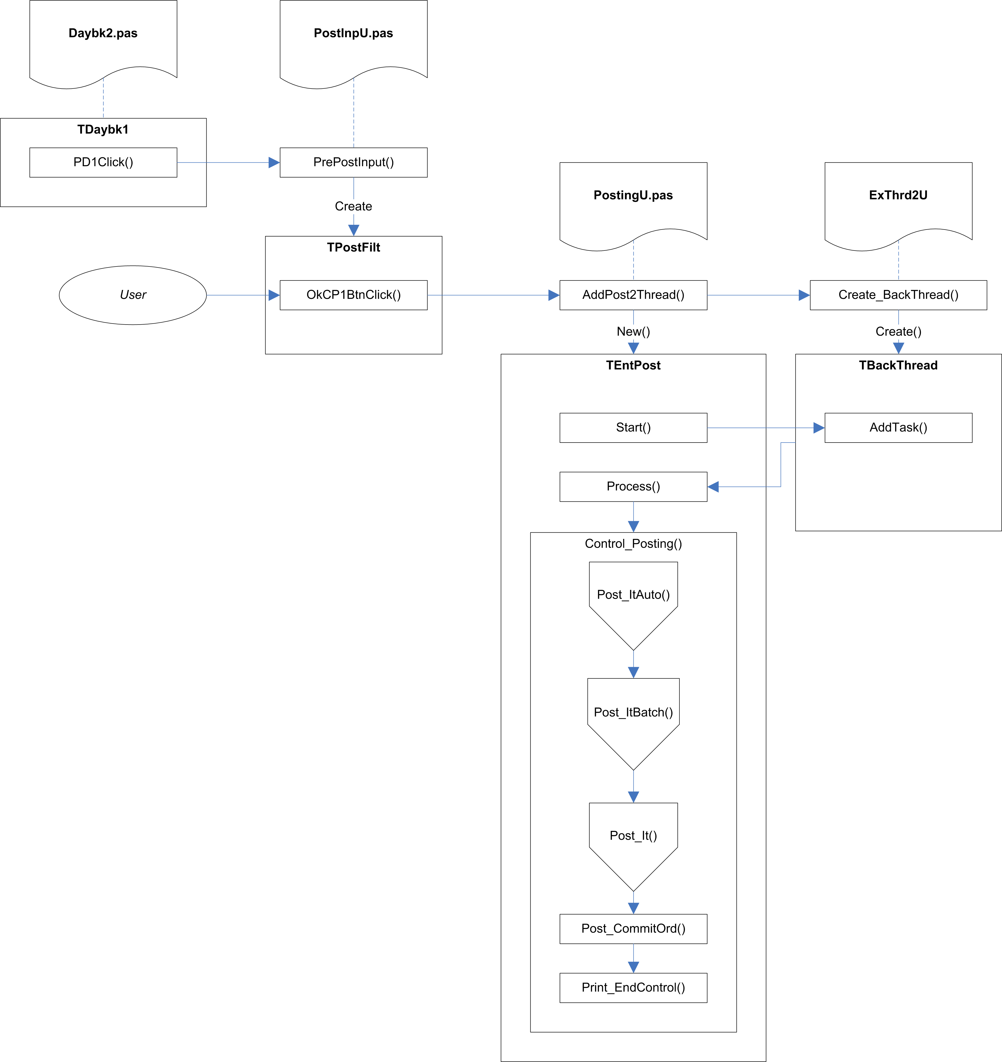

Fig.1 Overview

Details
The routine starts when the user clicks the Daybook Post button on the DayBook dialog. If the routine is activated from the Auto-Transactions tab, a flag is set to indicate that transactions should be created from all active Auto-Transactions in range, but that an actual DayBook Post should not be carried out.

Prepare and display the filter dialog
The filter dialog is displayed, to allow the user to select which document types are to be processed. By default, all the document types relevant to the posting mode (Sales, Purchase, Nominal, or Stock Adjustment, depending on where the Day Book Posting routine is called from) are selected.

The ‘Separate Posting Control Entries’ checkbox on the filter dialog is defaulted to the value stored in SepRunPost in System Settings (Syss). Checking or unchecking this checkbox will automatically update the System Settings value as well. This setting determines whether transaction lines for one G/L code are consolidated or added as individual lines.

Prepare the list of document types
The list of document types selected by the user is stored.

If a JRN document type is found in the set, it is removed, and a flag is set to indicate that Job Costing is to be included in the posting run.

Add to the thread queue
The DayBook Post task is added to the thread queue. The thread manager will activate the task when it reaches the top of the thread queue.

Prepare and display the Job Costing options dialog
If Job Costing is enabled, the Job Details table is checked for any records waiting to be posted.

If any records are found, the Job Posting Filter dialog is displayed, to allow the user to specify the Job Costing options.

Add the Job Costing task to the thread queue
When the user clicks Ok on the Job Posting Filter dialog, the details are stored, and a Job Costing task is added to the thread queue.

Control Posting (PostingU.pas)
This is the main DayBook entry-point, and is called (indirectly) by the thread queue manager when ready.

Check any hook points
The Cost of Sales G/L Code hook point, Adjustment G/L code hook point, and Line Date Protection hook point are checked to see if they are enabled. The last one acts simply as a flag to decide whether or not line dates should be synchronised with header dates. The first two will result in the appropriate hook points being called when they are reached.

Process Auto transactions
If the DayBook Posting routines were launched from the Auto-Transaction tab of the DayBook dialog, transactions are created for all the active auto transactions for the selected document types and date or period.

In this case, the Daybook Process ends at this point – transactions are created from the auto-transactions, but are not actually processed.

Otherwise transactions are created for auto-transactions which have AutoPost set to True, for the selected document types and date or period.

Process batch transactions
The Post_ItBatch method is called, which sets the allocation status and run number for all the transactions in the batch.

Process transactions
The Post_It method is called to do the main posting of transactions.

Auto-Transactions

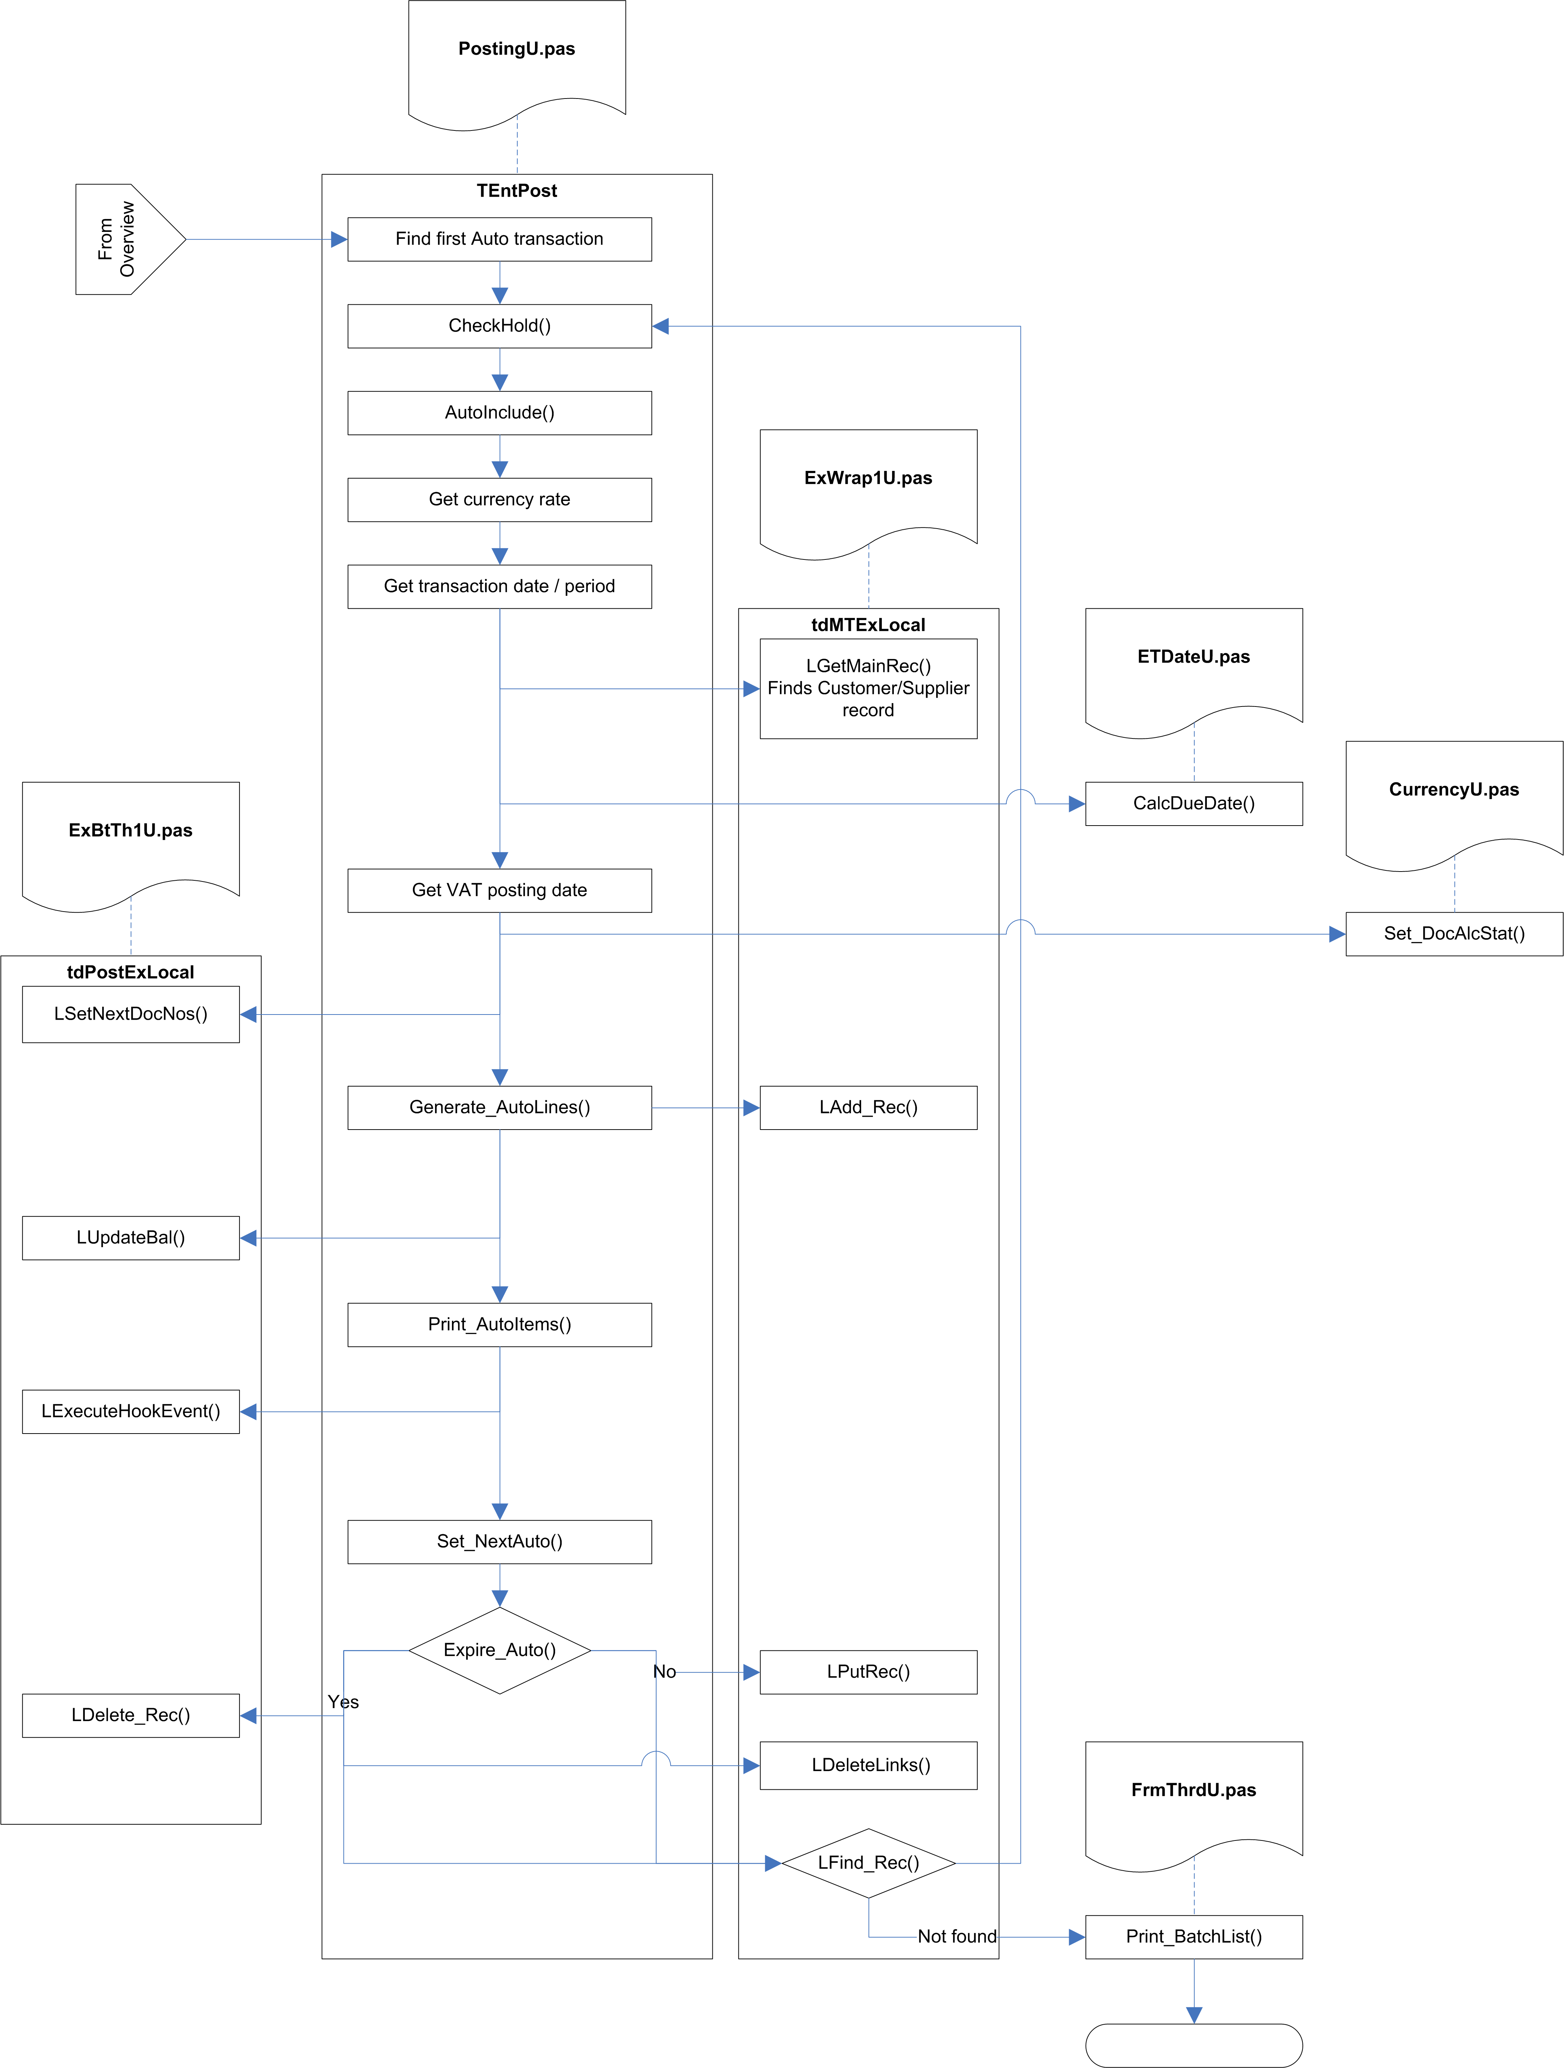

Fig.2 Post_ItAuto

Auto Transaction Posting

Prepare job-costing
If the JobCostOn (VarConst.pas) global flag is set to True, the Job Costing system is initialised.

Prepare notification hook
The HookNotify flag is set to True if the Notify Auto SIN hook point is enabled.

Adjust list of document types
A copy is taken of the currently selected set of document types. If SIN transactions are included, the SQU document type is added to the list. If PIN transactions are included, the PQU document type is added to the list.

Prepare print forms
An instance of TPFormList is created, in a ThisFList local variable. This maintains a list of reports to be printed.

Locate first Auto record
It then searches for the first Auto transaction. It does this by looking for the first record in Document.Dat which has a Auto-Run number (-2), and a folio number greater than
-2147483647 (FirstAddrD constant in X:\SBSLib\Win32\Btrvu2.pas).

Check for on-hold or suspended
The CheckHold function is called to check if the current transaction record is on hold.

CheckHold checks if the HoldFld field contains any of the On Hold values (1, 2, 3, 5, or 6), and returns True if it does.

Save record position
The record position is now saved. This is because the following sections will be creating a new transaction record, based on the information stored in the Auto record. After this record is added to the file, the record position will be restored to take us back to the Auto record that was being processed.

Read and adjust currency rates
If the document type is not a nominal posting (NMT/NOM), the currency rates are read from the System Currency Setup (SyssCurr), along with the triangulation rates for Euro conversion. If the document type is not one of the direct payment types (SRF,SRI,PRF,PPI, as read from the DirectSet constant in X:\SBSLib\Win\ExCommon\VarComnU.pas), then the Company Rate is set to zero.

Determine period/year or date
The AutoIncBy indicator is checked to determine whether we need to calculate the Transaction Date or the Period, and either converts the date to a period/year, or converts a period/year to a date. This triggers a hook point to allow the returned period/year or date to be amended.

Calculate the due date
The customer/supplier record is located and read. The due date is calculated based on the transaction date and the customer/supplier’s payment terms.

Payment terms usually holds the number of days credit for the customer/supplier. There is a special system in place for payment on a specific day of the month. This involves using a payment terms value greater than 500, in which case the correct value is calculated on the following basis:

900 + n = nth day of the following month.
800 + n = nth day of the second month following.
700 + n = nth day of the third month following.
600 + n = nth day of the fourth month following.
500 + n = nth day of the fifth month following.

Store operator name
The current log-in name is stored in the OpName field of the Document record.

Determine VAT date
If the VAT Scheme indicator in the System Setup indicates that VAT on Cash Accounting is in use (that is, if SyssVAT.VATRates.VATScheme holds ‘C’), and if the current document is one of the direct payment types (SRF,SRI,PRF,PPI), then the VAT date is calculated.

Currently, this is simply read from the System Setup (SyssVAT.VATRates.CurrPeriod), but in future it will be calculated using the CalcVATDate function in SysU1.pas – this function calculates and returns the VAT date based on the supplied transaction date. If the transaction date indicates a date in advance of the current period, it returns the last day of the month that the transaction date actually falls in.

The UntilDate is set to today, to indicate that this transaction was fully allocated at this date.

Set document allocation status
If the document is in the Allocation set (PIN, PCR, PJI, PJC, PPY, SIN, SCR, SJI, SJC, or SRC), the AllocStat field is set to ‘S’ for supplier or ‘C’ for customer, and #254 is stored in the UntilDate field. For other document types the AllocStat field is set to #0, and the UntilDate field is left unchanged.

If the System Setup authorisation mode holds ‘A’, and the HoldFlg value does not indicate that the record in on hold, the HoldFlg value is set to HoldP – Authorise Payment.

Assign next document number
The next available document reference is calculated for the current document type.

The document number is located and updated in the Increment table. A full reference number is calculated based on this number.

The reference number is created using the following recipe:

- Get the next available document number.
- Convert this to a string.
- If the string is more than 6 characters long:
    - Extract the first two characters of the string.
    - Convert them to a number.
    - If this number is less than 33 and greater than 10:
      - Subtract 10.
      - Use the result as an index into an array of characters (A to Z, excluding I, O, and S).
      - Store the indexed character as the suffix.
      - Copy the next 5 characters from the string, as the trailing string.
      - Convert them to a number.
      - Convert the result back into the trailing string.
    - Concatenate the document type string, the suffix, and the trailing string.
    - Return the result as the new reference.

The resulting reference is searched for in Document, to make sure it does not already exist. If it does exist, another next reference number is obtained – this continues until a unique reference is found.

Assign next folio number
This works in a similar fashion to the document reference, but folio numbers are integers rather than strings, so the check for duplicate numbers is different.

The folio number is located and updated in the Increment table.

If the current document type is SBT, PBT, SQU, PQU, ADJ, SOR, POR, SDN, PDN, or TSH, then the Folio Type which is searched for when checking for duplicates is AFL, otherwise it is FOL.

The Document table is searched for a match with the Folio Number, using the Folio Index. Because this index is an integer, the folio number is converted into a string with an embedded binary number as the search key, with any trailing #0 bytes removed.

Generate transaction lines
Transaction lines are added to the generated transaction.

The transaction lines against the original Auto transaction are located (using the Folio Number).

For each line, the record position is stored, and the line is then updated with the details from the generated transaction. If the transaction is a nominal transation (NMT/NOM), the currency rates are read from the system settings, along with the matching triangulation rates. If the transaction is not a nominal transaction, these rates are read from the transaction header record instead.

The transaction line is then saved as a new record, and the original record position is restored, ready to move on to the next Auto transaction line.

Save transaction
The transaction is now saved as a new record.

Update balance
If the System Setting UpBalOnPost is True (indicating that customer/supplier balances should only be updated on a post, rather than being updated straight away), this section is ignored.

This section is also ignored if the current document type is a quote (SQU or PQU), or is a Sales or Purchase Order transaction (SOR, POR, SDN, or PDN).

Otherwise, the customer/supplier balances and the history records are updated (see Update Balance below).

Print report
If the transaction is one of the auto-print transactions (SIN, SCR, SRI, SRF, SQU, SOR, SDN, PPY, PQU, POR), a print task is added to ThisFList. This print task will be activated at the end of the DayBook Posting routines.

Call hook point
If the After Auto SIN Created hook point is enable, the hook event is triggered.

Update or delete auto transaction
The transaction record is locked.

The auto transaction date/period is moved forward. The AutoIncBy field of the transaction record is used to determine whether the date is advanced by period or by date, using the AutoInc field as the actual increment value (either periods or days).

The Until Year/Period or UntilDate is checked to see if the new period or date would be past the expiry date. If it is, the auto transaction record is deleted (along with its accompanying transaction lines), otherwise it is saved with new period/date and unlocked.

Locate next auto record
The routine looks for the next auto transaction record, and if it finds one it goes back to the Check for on-hold or suspended section.

Print reports
If there are no more auto transaction records, the list of reports in ThisFList is passed to the Print_BatchList function (in FrmThrdU.pas) for printing via the thread queue.

Update Balances

Locate the customer/supplier record
This first tries to find and lock the current customer/supplier record. If this fails, it assumes that this is because the lock failed (another user or process was editing the record). The routine still continues, as the record lock is only required to allow the ‘last edited’ details to be updated – if another user is editing the record, these details will be left alone.

Prepare the credit/debit amounts
A local array, CrDr[], is used to hold the credit and debit values.

If the balance adjustment is negative, the Credit element (CrDr[True]) is filled with the unsigned amount, otherwise the Debit element (CrDr[False]) is filled with the amount.

If the current document type is a direct transaction (SRF, SRI, PRF, PPI), then the opposite element of the CrDr[] array is filled with the unsigned amount as well.

This array is used as the source of the values for the actual updating.

Provided the Account Year for the transaction is after the last purge year, the history records can be posted.

Update the balance history
Several calls are now made to Post To History and Post To Year-To-Date (see below).

First, the basic balance for the customer/supplier is updated, for the year and period concerned. The matching year to date balance is also updated.

The debtors/creditors control account is updated. If the customer/supplier has overridden the default debtors/creditors control account then this overriding account is used, otherwise the balance is stored against a control account of zero. The matching year to date balance is also updated.

For transactions which affect the Stock tree (SIN, SCR, SRF, SRI, SJI, SJC, SDN, PIN, PDN, PCR, PRF, PPI, PJI, PJC), the Customer/Supplier Gross Profit balance record for the year and period is updated. The matching year to date balance is also updated.

Update ‘last edited’ flag
If the Customer/Supplier record was successfully locked at the start of this routine, then the ‘Last Edited’ flag on the record is updated with the date and time. The record is then unlocked.

Post To History
The history table contains a history of balances, split into multiple categories (e.g. by customer/supplier, by cost centre, by department). This routine updates the history table with the supplied balance details.

Locate history record
This first tries to find an existing record against the type, code, currency, year, and period. If it cannot find an existing record, it adds a new one. If the period indicates that this is a Year To Date transaction (not possible for Daybook Posting?), Year To Date records will also be added for any years previous which do not yet have them.

The record is then locked.

Calculate balances
The Previous Balance is calculated from the existing Sales and Purchases values. These are then updated with the passed in values, rounded up to 2 decimal places.

The record is saved and unlocked.

Post To Year To Date
This calls Post To History for the specified type, code, currency, and year, with the period set to indicate a year-to-date entry. It also recursively calls itself to post to any future years which are included in the data set.

Timings
These two functions are called repeatedly – usually several times for each transaction – throughout the course of the DayBook Post, and account for the majority of the time taken by the routines.

We attempted to speed this up by accumulating the values in memory, instead of posting them immediately, and then posting them at the end of the main routines. This proved to have very little impact on the time taken (and is possibly not a viable solution anyway).

The code for the history posting routines (edited for clarity) appears at the end of this document.

Batch Transactions

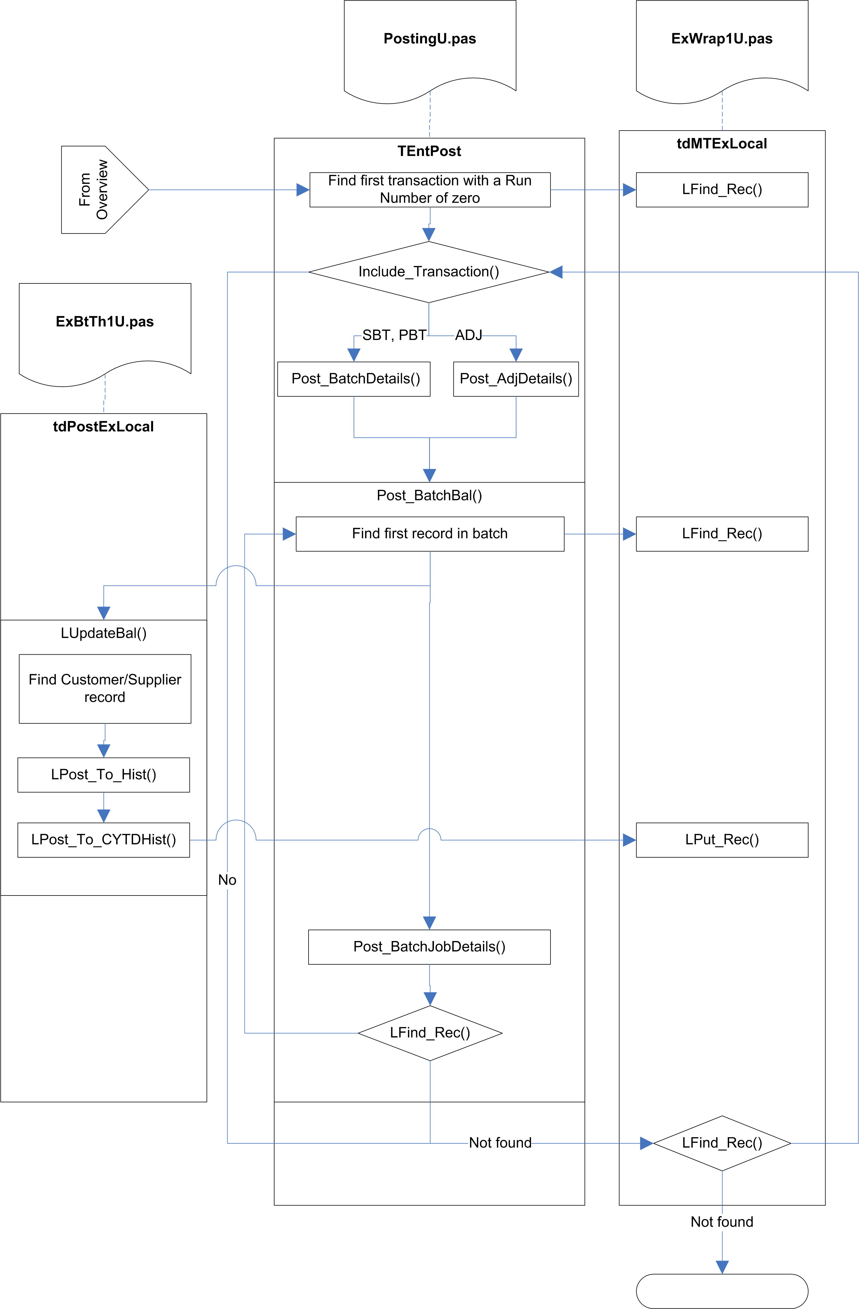

Fig.3 Post_ItBatch

Allocate Batch Transactions

Prepare job-costing
If the JobCostOn (VarConst.pas) global flag is set to True, the Job Costing system is initialised.

Locate first batch record
The routine searches for the first transaction with a run number of zero (indicating an unposted transaction).

Increment PostingCount
The PostingCount variable keeps track of the number of transactions actually posted, and is eventually used for updating the progress display in the main posting routing (Post_It).

Update LastFolio
If the current transaction has a folio number greater than the current LastFolio number, LastFolio is updated with this folio number.

The LastFolio value will be used in the main posting routines to check for and ignore transactions that were added after the posting run was started (because the DayBook Post is run from a thread it is possible for the user to add transactions which the DayBook is being processed).

Check transaction
The Include_Transaction routine is called to determine whether the current transaction should be included in the posting run.

Included transactions are:
- Document type SBT, PBT, or ADJ
- Not on hold or suspended
- Not for a future period
- Not for a past period, unless the system flag to allow posting into previous periods is set.
- Not for a future transaction date
- Not in a purged period
- Not before the last audit date

Lock record
The transaction record is locked. If it cannot be locked for any reason, it is simply ignored.

Post details
For document types SBT and PBT, the Post Batch Details routine is called. For document type ADJ, the Post Adjustment Details routine is called.

Save record
The current transaction record is locked, and the run number is updated. The record is then saved and unlocked.

Update customer/supplier balance
If the batch has not already been posted, the balances and Job Actual values are updated for each transaction in the batch.

Next record
The next batch transaction record is located and, if found, we loop back to Increment Posting Count.

Post Batch Details

Locate batch transactions
The OurRef of the transaction record is used to find the first transaction for this batch.

Lock record
The record is locked. If this fails, the record is simply ignored.

Determine VAT Date
If the VAT Scheme indicator in the System Setup indicates that VAT on Cash Accounting is in use (that is, if SyssVAT.VATRates.VATScheme holds ‘C’), and if the current document is one of the direct payment types (SRF, SRI, PRF, PPI), then the VAT date is calculated.

Currently, this is simply read from the System Setup (SyssVAT.VATRates.CurrPeriod), but in future it will be calculated using the CalcVATDate function in SysU1.pas – this function calculates and returns the VAT date based on the supplied transaction date. If the transaction date indicates a date in advance of the current period, it returns the last day of the month that the transaction date actually falls in.

The UntilDate is set to today, to indicate that this transaction was fully allocated at this date.

Set document allocation status
If the document is in the Allocation set (PIN, PCR, PJI, PJC, PPY, SIN, SCR, SJI, SJC, SRC), the AllocStat field is set to ‘S’ for supplier or ‘C’ for customer, and #254 is stored in the UntilDate field. For other document types the AllocStat field is set to #0, and the UntilDate field is left unchanged.

If the System Setup authorisation mode holds ‘A’, and the HoldFlg value does not indicate that the record in on hold, the HoldFlg value is set to HoldP – Authorise Payment.

Save record
The record is saved and unlocked.

Update customer/supplier balance
If the System Setting UpBalOnPost is True (indicating that customer/supplier balances should only be updated on a post, rather than being updated straight away), or if a Btrieve Transaction was used, this section is ignored.

The Update Balance method is called to do the actual updating.

Update Job Costing
If Job Costing is active, the Post Batch Job Details method is called. This calls Update Job Actuals (see below) for each transaction line of the current transaction.

Find next record
The next transaction record is located, if any, and the routine loops back to Lock record.

Update Job Actuals

Locate record
This locates a record which matches the Folio Number and Absolute Line Number of the transaction line. If no record can be found, a new record will be added, otherwise the record is locked.

Check transaction line
The Job Actual record will only be created or updated if the transaction line fulfils the following requirements:

- A Job Code is specified.
- NomAuto is set to True.
- The line number is greater than or equal to zero, or the document type is not one of JCT, JST, JPT, JSA, or JPA.
- The document type is not JPT.
- The document type is not JST, unless DeliverRef is non-empty.
- The document type is not one of JSA, or JPA, unless the line number is zero.
- The document type is not one of SRN, or PRN.

Assign/calculate values
The Job Actual values are copied from the transaction line. Qty, Cost, Charge, and Uplift values are recalculated, based on the document type and on additional information looked up in the JobMisc, Stock, and Customer/Supplier tables.

Save record
The Job Actual record is saved or added, and the lock is released.

Post Adjustment Details
This routine creates a nominal transfer record, if required, for the current transaction.

Check Stock Valuation flag
The AutoValStk system setting is checked. If this is True, a Nominal Transfer record is required.

Create Nominal Transfer record
The actual record is created, copying the details from the current transaction header, and marking the transaction as external document (to prevent user-editing of it).

Locate transaction lines
The transaction lines against the current transaction are located and processed.

Update history
The various balance history records are added or updated, based on the current transaction line, using Post To History and Post To Year-To-Date. For some lines, the Customer / Supplier / CostCentre / Department balance history records are also updated, using Ctrl_CuStkHist.

Substitute stock parameters
The stock location record is found, and if necessary the nominal codes are copied across from the location record to the stock record.

Get nominal codes
The nominal codes are retrieved either from the Stock record or from the BOM parent record (if one exists).

Call hook point
If the Adjustment Nominal Code hook point is enabled, the hook point is called to allow the nominal codes to be changed.

Add stock valuation lines
Stock valuation lines are added.

This searches all transaction lines for a match with the Stock Valuation Code (-21), the Nominal Code (either Closing Stock or BOM GL), and the Cost Centre and Department of the current stock item.

If a match is found, the Net Value is updated.

If no match is found, or if the Separate Control Posting system flag is set to True, a new Nominal Transfer transaction line is created and the values are copied into it.

Add Job Costing uplift
If the current transaction line has a Job Code, and the matching Job Actual record contains an Uplift value, a stock valuation line is added for this as well.

Finalise transaction line
The Folio Number of the transaction is copied to the B2BLink field of the line.

It then searches for the next transaction line and loops back to Update history.

Finalise transaction
If Auto Stock Valuation is active, Reset_NomTxfrLines in RevalU2U.pas is called to set the run number for the transaction lines.

Main Posting

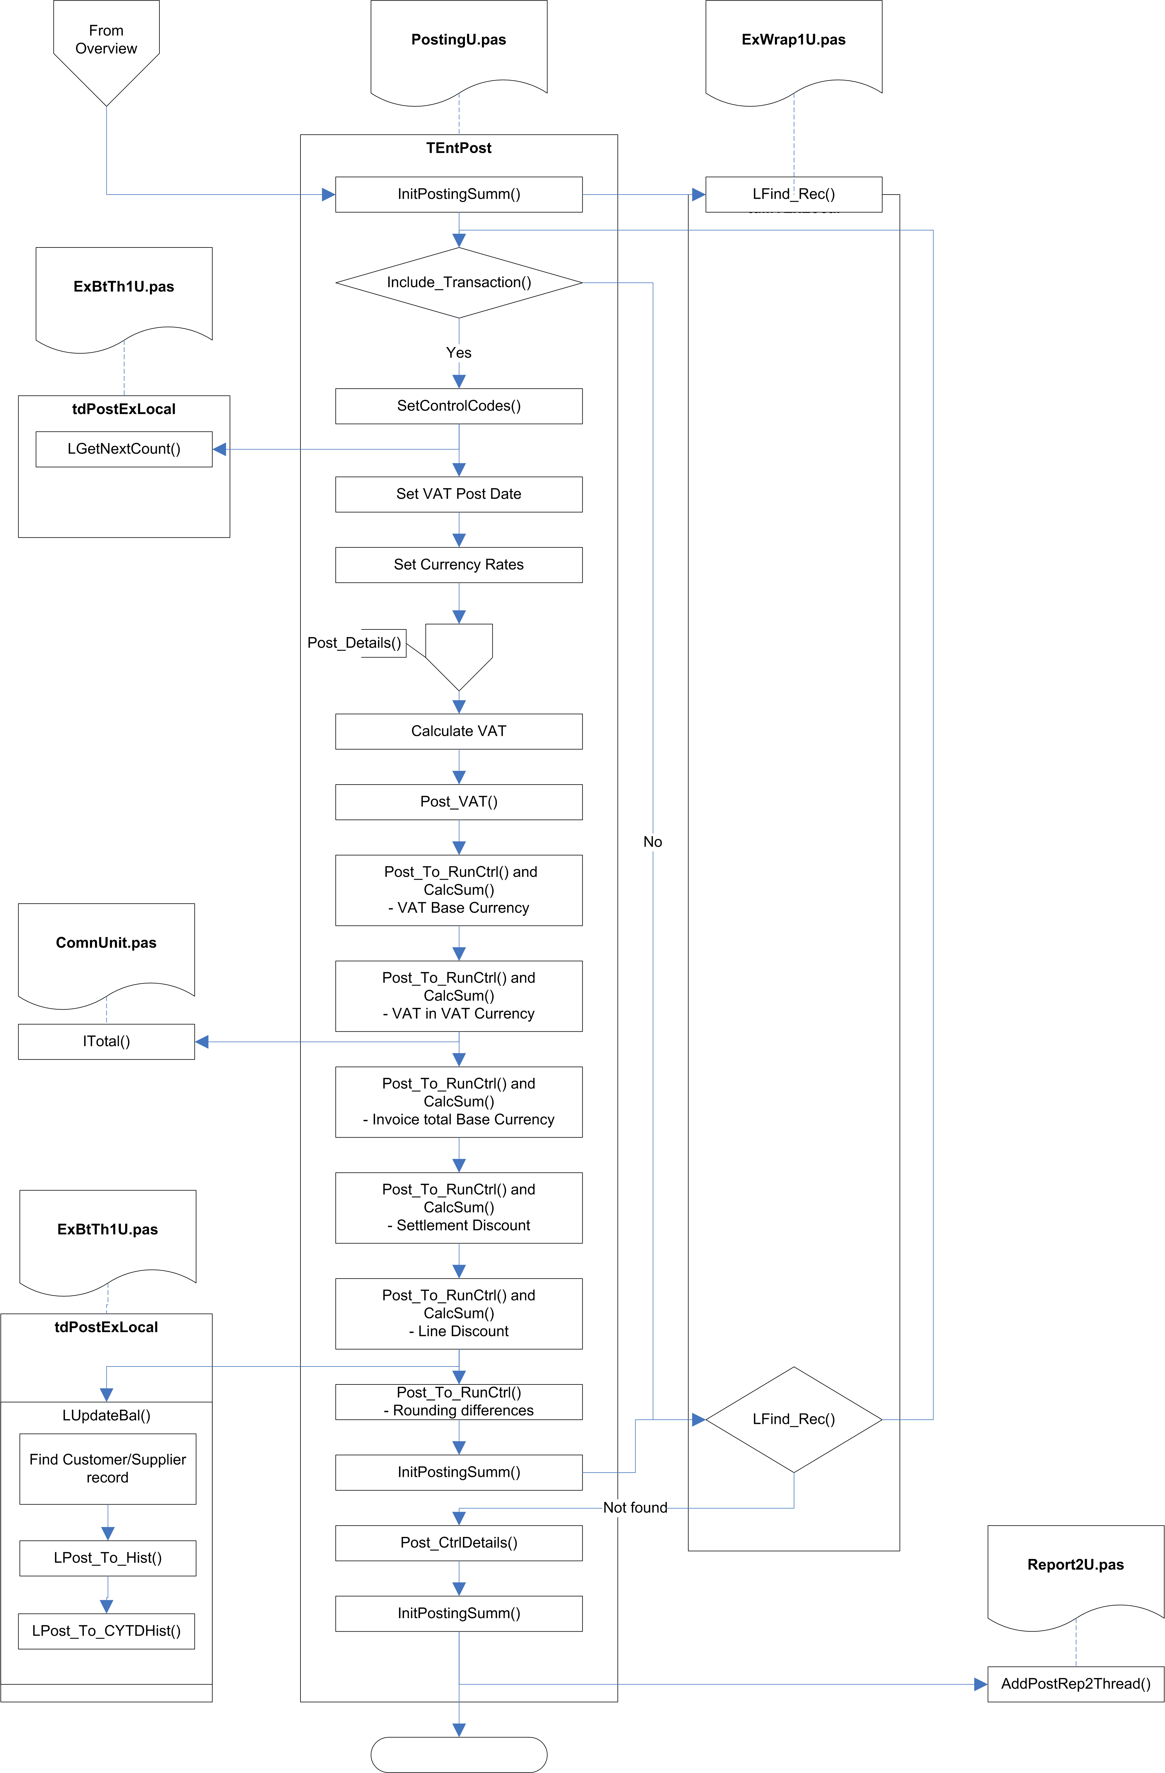

Fig.4 Post_It

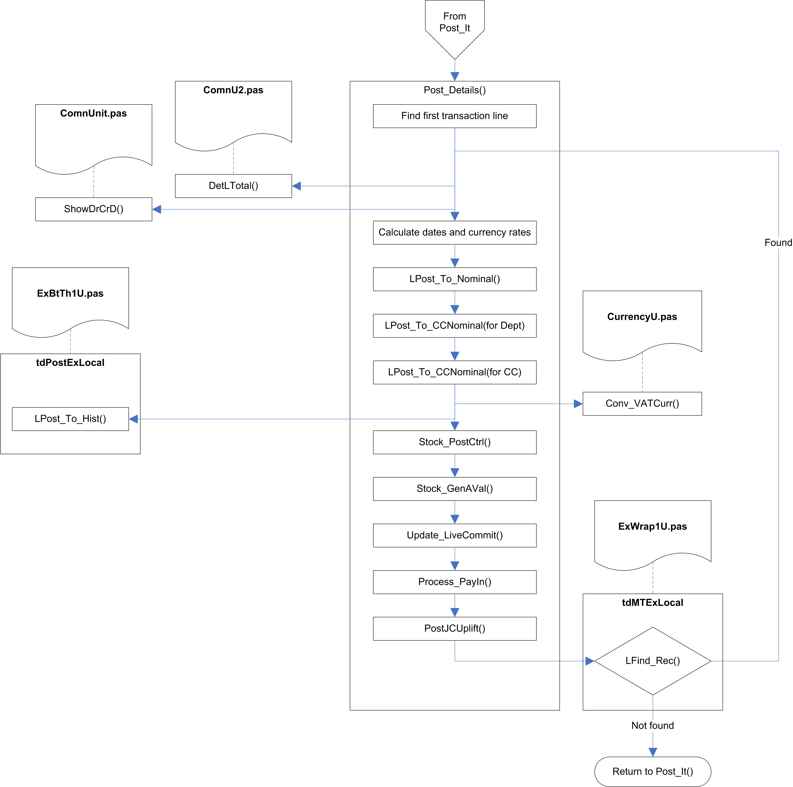

Fig.5 Post Details

Main Transaction Posting

Initialise
The thread queue progress is initialised, and the Posting Summary array is initialised (all the values are set to zero).

The first transaction with a run number of zero is located.

Check transaction
The item count and progress are updated.

The Include_Transaction routine is called to determine whether the current transaction should be included in the posting run.

Included transactions are:
- One of the selected document types
- Not on hold or suspended
- Not for a future period
- Not for a past period, unless the system flag to allow posting into previous periods is set.
- Not for a future transaction date
- Not in a purged period
- Not before the last audit date

If the transaction record is marked as suspended, the DayBook Posting stops with that transaction and does not process any more transactions.

Prepare transaction for editing
The transaction record is locked, an array of G/L codes relevant to the transaction type is populated, and the next run number is read from the Document Numbers table. The posting date is set to the current date.

If cash accounting is not being used, the VAT Post Date is set.

The currency rates are read from the system defaults.

Post transaction lines
The Post Details method (see below) is called to process all the lines for the current transaction.

Post control code lines
Additional transaction lines are added, calculating the appropriate values, for:

VAT in Base Currency
VAT in VAT Currency
Invoice Total in Base Currency
Settlement Discount
Line Discount
Rounding Differences

Finalise transaction
The CIS Date is set, the transaction record is stored and unlocked.

If there are more transactions, the next transaction is found, and the system loops back the Check transaction.

Post Nominal Codes
For every nominal code, this locates all the transaction lines from the current run, and calls Post_To_Nominal for each one, which updates the balance history for the G/L code, and for all the parent entries above the G/L Code in the G/L tree.

Print summary report
A report is created from the Posting Summary array, and passed to the thread queue for processing.

Post Details

Locate first transaction line
The supplied Folio Number is used to locate the transaction lines for the current transaction.

Calculate totals
The total for the line is calculated, then the other values are calculated – Debit/Credit, Cleared, etc. – along with the Year and Period and the conversion rates.

The line total net value is calculated.

Update balance history
The various combinations of Cost Centre and Department balance histories are updated, using the Post To History and Post to Year-To-Date functions (see above).

The transaction line is saved.

The VAT history is calculated and stored using Post To History.

The various balance history records are added or updated, based on the current transaction line, using Post To History and Post To Year-To-Date. For some lines, the Customer / Supplier / CostCentre / Department balance history records are also updated, using Ctrl_CuStkHist.

If Stock Auto Valuation is active, additional lines are created for Cost Of Sales control codes. A hook point is called for each line, to allow plug-ins to change the assigned Cost of Sales control code.

Process pay-in lines
If the UsePayin system-settings flag is True, pay-in transaction lines are generated.

Process job costing
If Job Costing is active, the current line is checked to see if Uplift is required, and if so, additional transaction lines are created as control lines.

Finalise transaction line
The transaction line is unlocked, and the next transaction line is located. Assuming more lines are found, the system loops back to Calculate totals.

History Posting Code
The following is a kind of Pascal pseudo-code version of the history posting routines, with extraneous details (mainly error-handling) removed, and with some other adjustments to try and make it fairly clear what the routines are actually doing.

procedure PostToHistory(NType : Char;
NCode : Str20;
PPurch : Double;
PSales : Double;
PCleared : Double;
PCurrency: Byte;
PYear : Byte;
PPeriod : Byte;
var PrevBal : Double);
var
SearchKey: Str255;
DecPlaces: Byte;
begin
SearchKey := FullHistoryKey(NType, NCode, PCurrency, PYear, PPeriod);

DecPlaces := 2;

Found := Find_Rec(History, B_GetEq, SearchKey);

if (not Found) then
AddHistoryRecord(NType, NCode, PCurrency, PYear, PPeriod);

{* Adjust Rounding on Stock Qty Calculations, Cleared = Qty count *}
if (History.ExClass in
StkProdSet + [StkGrpCode, StkDescCode, StkStkQCode, StkBillQCode, CuStkHistCode]
+ [CommitHCode, JobGrpCode, JobJobCode]) then
DecPlaces := SystemSettings.NoQtyDec;

PrevBal := History.Purchases - History.Sales;

History.Purchases := Round_Up(History.Purchases +
Round_Up(PPurch, 2), 2);

History.Sales := Round_Up(History.Sales +
Round_Up(PSales, 2), 2);

History.Cleared := Round_Up(History.Cleared +
Round_Up(PCleared, DecPlaces), DecPlaces);

Put_Rec(History);

end; {Proc..}

procedure PostToYearToDate(NType : Char;
NCode : Str20;
PPurch : Double;
PSales : Double;
PCleared : Double
PCurrency : Byte;
PYear : Byte;
PPeriod : Byte);
var
RunNumber: Double;
begin
RunNumber := 0;

PostToHistory(NType, NCode, PPurch, PSales, PCleared, PCurrency, PYear, PPeriod,
RunNumber);

if (LastYearToDate(NType, NCode, PCurrency, NextYear(PYear), PPeriod, True)) then
PostYearToDate(NType, NCode, PPurch, PSales, PCleared, PValue1, PValue2,
PCurrency, History.Yr, PPeriod);

end;

function LastYearToDate(NType : Char;
NCode : Str20;
PCurrency,
PYear,
PPeriod : Byte;
SearchForward: Boolean) : Boolean;
var
KeyChk,
KeyS : Str255;
B_Func : Integer;
Found : Boolean;
CEStatus: Integer;
begin
if (not SearchForward) then
B_Func := B_GetLessEq
else
B_Func := B_GetGEq;

KeyChk := PartialHistoryKey(NType, NCode, PCurrency);
KeyS := FullHistoryKey(NType, NCode, PCurrency, PYear, PPeriod);

CEStatus := Find_Rec(History, B_Func, KeyS);

Found := ((CEStatus=0) and
(CheckKey(KeyChk, KeyS, Length(KeyChk),True)) and
(((History.Year <= PYear) and (not SearchForward)) or
((History.Year >= PYear) and (SearchForward))) and
((History.Period = PPeriod) or (SearchForward)));

{* Check for the exact YTD as this returns next History which will be a period *}
if (Found) and (SearchForward) then
Found := CheckHistoryRecordExists(FullNHistKey(NType, NCode, PCurrency,
History.Yr, PPeriod));

Result := Found;

end;

procedure AddHistoryRecord(NType : Char;
NCode : Str20;
PCurrency: Byte;
PYear : Byte;
PPeriod : Byte);
var
LastPurch,
LastSales,
LastCleared: Real;
N: Integer;
const
YTD_Indicator = #255;
begin
LastPurch := 0;
LastSales := 0;
LastCleared := 0;

if (PYear > 0) then
begin

if (PPeriod = YTD_Indicator) and
(LastYearToDate(NType, NCode, PCurrency, PreviousYear(PYear),
PPeriod, False)) then
begin
N := (PYear - History.Year);

if (N > 1) then
for N := NextYear(History.Year, True) to PreviousYear(PYear, False) do
AddHistoryRecord(NType, NCode, PCurrency, N, PPeriod);

LastPurch := History.Purchases;
LastSales := History.Sales;

if (NType in [StkStkQCode, StkDLQCode, StkBillQCode,
JobGrpCode, JobJobCode]) then
LastCleared := History.Cleared;
end;

Clear(History);

History.ExClass := NType;
History.Code := FullNHCode(NCode);
History.Cr := PCurrency;
History.Yr := PYear;
History.Pr := PPeriod;
History.Sales := LastSales;
History.Purchases := LastPurch;
History.Cleared := LastCleared;

Add_Rec(History);

end;

end;

